How to Get Started:

The EasyBiz Website is http://easybiz.alaskaair.com .This is the website you will use when booking travel on Alaska Airlines.

To enroll your company:

- On the main sign-in page click “Enroll Now” on the right-hand side.
Fill in the information required. Under Company Name, enter University of Washington-Your Department
Name. If it is too long, feel free to abbreviate using UW-Department Name. Enter your company’s Federal
Tax ID number. A duplicate error message will prompt if your department already has an existing account.

- Please select your Industry Type, and Airline Sales Representative as how you heard about EasyBiz.

- Now, you will need to set up your My Account profile. This is your profile, which will enable you to sign into EasyBiz. Use your User ID for your Mileage Plan account if you already have one or set up a new one if you don’t. It only takes a few minutes, just follow the prompts.

It is okay to use your Mileage plan account to sign up for EasyBiz. We designed the program to allow users to access both programs using one log in. Mileage plan is your personal account while EasyBiz is your company’s account. The only thing the two accounts share is the log in. The forms of payment, personal information, personal mileage, etc. is all kept separate from the business EasyBiz.

- Please add the EasyBiz Website to your Favorites.

- To access UW’s contract state fares, email gina.olan@alaskaair.com your EasyBiz Company Name and EasyBiz number to have it activated.

Welcome to EasyBiz!

You must be signed into the EasyBiz Website for purchases to be recorded to your company EasyBiz travel reports and Mileage Plan account. Your EasyBiz company name will show on the top page when you’re signed-in correctly.

- To book a flight:
Click on the TRAVEL TAB and choose RESERVATIONS. On the far right column, under FARE TYPES & DISCOUNTS, click the arrow down to bring up a list of fare types & discounts.
- Clicking NONE will bring up all fares.
- Clicking on GOVERMENT FARES will only show government fares.
- Clicking on GOVERMENT & ALL OTHER FARES will bring up both government and all other fares.

To avoid having to make all the necessary choices, the Administrator can set your preference by:
- Going to the MY EASYBIZ TAB
- Clicking on CUSTOMIZE FEATURES below the tabs
- Under Customize Features, Click on EDIT FARE PREFERENCE
- Click the fare type you want displayed automatically
- Click SAVE to save your choices

The icon beside a fare means it is a government/state fare. You will need to use UW’s approved form of payment for this fare. For more info, please refer to http://des.wa.gov/services/Travel/Travel/Pages/default.aspx

If you are unable to see the government/state fares, make sure you have clicked on the “Refundable” tab on the upper left.

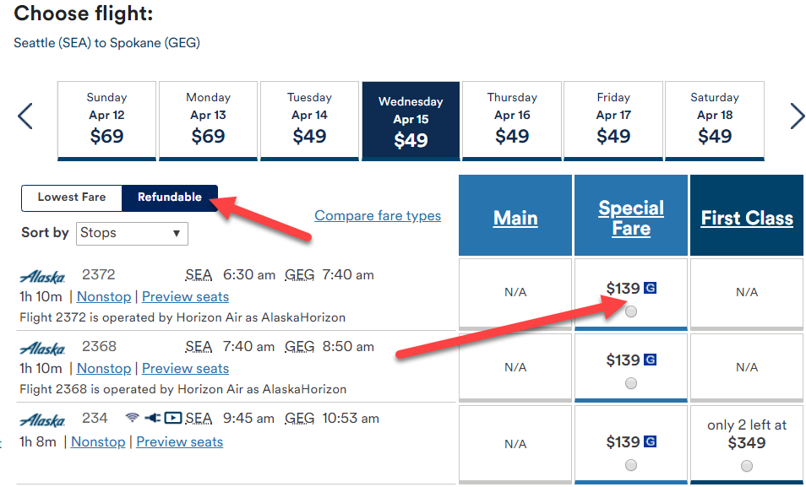

- Administrator and Assistant Administrator
As our main contact at your department/state agency, you are what we call the EasyBiz Administrator. You will want to invite an Alternate EasyBiz Administrator. This person has all the same functions and access as you (great as a back-up for when you’re out on vacation!).

Administrator and Assistant Administrator can:

- Invite or delete users. Arrange travel for yourself and others.
- Assign credit cards
- Access company mileage plan
- Access EasyBiz wallet
- Customize site features
- Access to ticket report information reports (unless you choose otherwise)
- Update company information

How to Invite an Alternate Administrator:
1. Once you’re signed into EasyBiz, click on the “MyEasyBiz” tab.
2. Click on “Invite an Alternate”.
3. Enter the person’s first name, last name, and email address. Click “Invite”. This will send an email to the person you have invited. The email contains directions and a link for them to respond to.

- Invite users as needed.

How to Invite New Users:
1. Once you’re signed into EasyBiz, click on the “MyEasyBiz” tab.
2. Click on “Invite Users”.
3. Enter the person’s first name, last name, and email address. Click on the box below the email address only if you want the user to have Ticket Report Access for All Users. This means the User will be able to see tickets made by every User within your department/state agency. If you do not want to give this access, then do not check the box. Click “Invite”. This will send an email to the person you have invited. The email contains directions and a link for them to respond to.

The Alternate Administrator and Users will need to have a My Account to begin using EasyBiz, just as you needed one to enroll your company in EasyBiz. When the invited user clicks on the link in the invitation email that is sent to them, they will be prompted to input their My Account User ID and password or to create an account if needed.

Once the invited users have filled out the My Account information, the Administrator will receive an email indicating that there are new EasyBiz Users.

- Credit Card

1. If desired, your company can store frequently used credit card(s) & billing information. All saved credit card information automatically appears at the time of ticket purchases for any of your users to select. You do not have to store any credit cards. If you do, only the last four digits of the card number (if entered), billing address, and phone number will be visible to the user. At the time of purchase, users can select to either purchase using a card stored on EasyBiz or input another card for payment.
2. Once you’re signed into EasyBiz, click on the “MyEasyBiz” tab, then click “Credit Cards & Billing Addresses”.
3. Click on “Add a Credit Card”.

- EasyBiz Wallet

Unused tickets can be deposited in the EasyBiz wallet for future use. Unused tickets are subject to existing change fees. Change fees are waived for MVP Gold members. Only the Administrator and Alternate are authorized to redeem funds in the wallet and are subject to the expiration of the original ticket value.

- Customized Features and Custom Fields

1. Once you’re signed into EasyBiz, click on the “MyEasyBiz” tab, then click “Show All”, then Customize Features”. Click on “Add a Custom Field”.

2. Custom fields are used to add supplemental or reference information when purchasing a ticket. This information appears within the EasyBiz ticket report. Define these fields yourself based on your department needs. Examples of custom fields include: travel authorization code, department code, budget code, purchase order number, or travel reason. These fields can be indicated as required or optional and displayed on the checkout page.

Reports
You can view a ticket purchase report online or download the report as an Excel document and sort the data by various fields. EasyBiz Users view a record of their ticket purchase history, while other users’ purchases remain confidential. Administrators access ticket purchase information for all users. Administrators may grant select EasyBiz Users special access to All User Ticket Reports, if desired.
The Ticket Report contains the following information:
- Ticket number
- Confirmation code
- Passenger first/last name
- Issue date
- Fare
- Tax
- Change fee
- Total
- Ticket status
- EasyBiz User who made purchase
- Form of payment code
- Form of payment
- Itinerary
- Custom fields input

It is important to remember that the online EasyBiz reports can only track tickets purchased, changed, or refunded through the EasyBiz website. The reports do not capture information on changes or refunds made through our Reservations department.

Other Important Things to Know About EasyBiz:

Mileage Plan
The Administrator and the Alternate are the only people authorized to redeem a Mileage Plan award. An award may be redeemed in anyone’s name. The company’s miles are redeemed similarly to a personal Mileage Plan account. Miles may be redeemed for travel on Alaska and Horizon, as well as partner carriers.

You, as the Administrator or Alternate Administrator, may check your mileage level and redeem awards online through your EasyBiz Website. Simply refer to the “MyEasyBiz” tab on your EasyBiz site. The site will only let you redeem an award if you have enough miles to do so.

Help
Help is just a phone call away. Just click on the Help tab on the EasyBiz site, then select Help Desk.
Questions about forgotten User ID and Passwords should be directed to the Web Help Center at 1-877-502-5357.

Let Us Know
You, as the EasyBiz Administrator, are our main contact at your department. Should you change job responsibilities or leave the department, please notify the Web Help Desk so that we may establish a new Administrator.

On behalf of all of us at Alaska Airlines, thank you for your business!

