Ariba eTravel Changes 02/22/2019
All implemented changes are based on concerns regarding compliance with the State
travel policy and various Federal Agency requirements, feedback from campus, and data
compiled over the past year.
We will continue to address policy concerns and campus feedback with future ARIBA
eTravel enhancements. Please send all questions and concerns to travel@uw.edu

Table of Contents
Remove I-94 consent from visa type ‘Not entering or leaving the US’ 3
Rename the ‘Reset Per Diem’ button 3
Update ‘incorrect travel dates/per diem rate’ error message 4
Fix ‘Abstract Fee’ Object Code 4
Increased allowable attachment size 5
Changes to traveler type ‘Relocation’ 5
Update Ariba Report: Expense Details Grouped by Expense Report 5
Don’t allow a negative amount to be entered for ‘per diem advance received’ line item 6
Change the wording of ‘Policy Violations’ 6
Tag additional conditions as ‘Policy Justifications’ 7
Fix instruction in ‘Package Deal’ line item 8
Add cancellation fee to ‘lodging per diem’ line item 9
Travel Office approval flow flag changes 10
Add per diem city and state/country to print version and line item 11
Changes to ‘meals paid for others’ line item 12

Remove I-94 consent from visa type ‘Not entering or leaving the US’
I-94 not required when traveler is not entering or leaving the US.
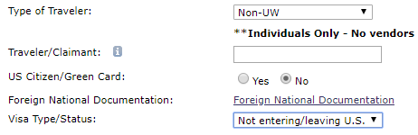
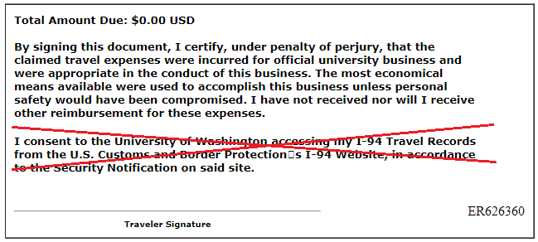

Rename the ‘Reset Per Diem’ button
Button allows user to edit details, does not reset the line item.
Old: New:
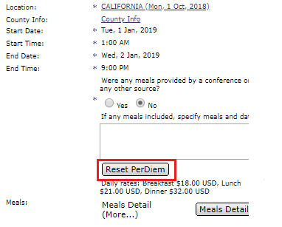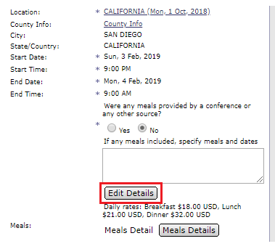

Update ‘incorrect travel dates/per diem rate’ error message
Cleaned up the language for clearer instruction.

Meal per diem
Old: New:
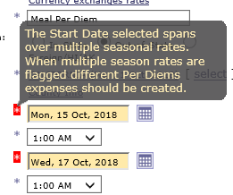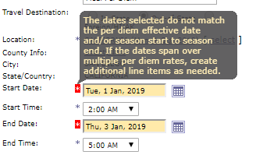
Lodging per diem
Old: New:
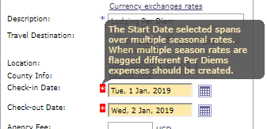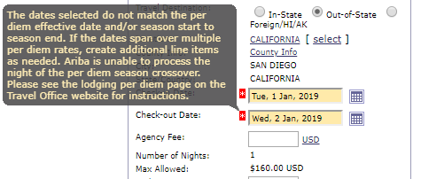

Fix ‘Abstract Fee’ Object Code
Changed from 04-16 to 03-34.
Old: New:
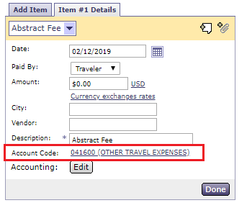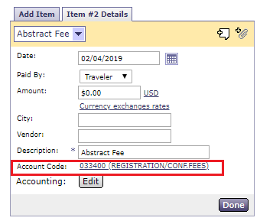

Increased allowable attachment size
File size per attachment limit increased from 4 MB to 10 MB (10,240 KB)
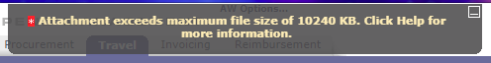

Changes to traveler type ‘Relocation’
Traveler type ‘relocation’ removed as traveler type:
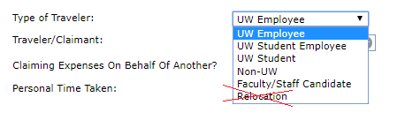
Question added to summary section:
Answer ‘yes’:
Answer ‘no’ will allow user to continue

Update Ariba Report: Expense Details Grouped by Expense Report
Add 3 new filters to this report (Preparer, traveler, budget #):
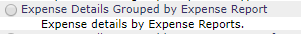
Old: New:
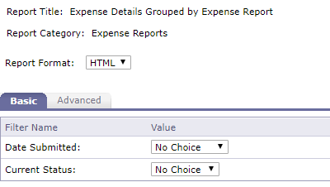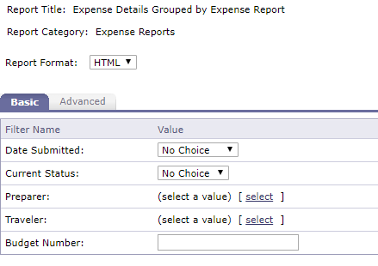

Don’t allow a negative amount to be entered for ‘per diem advance received’ line item
When entering the value as a positive value Ariba automatically converts it to be a negative (as it should). This change prevents the error of entering it as a negative value.
New:
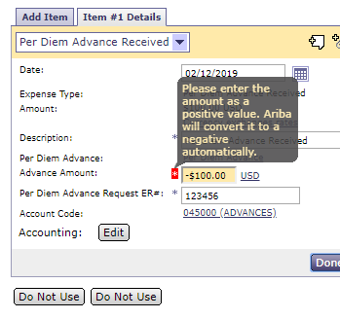

Change the wording of ‘Policy Violations’
Changed wording from violation to ‘justification’. These aren’t violations, they are justifications/additional information being provided for compliance.

Old: New:
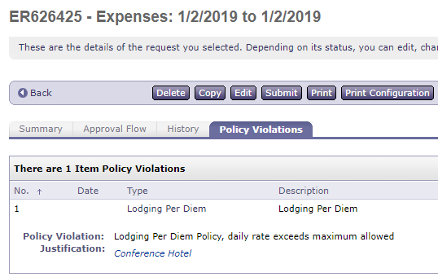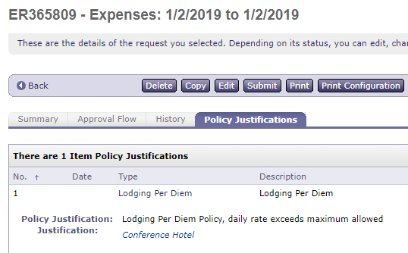

Tag additional conditions as ‘Policy Justifications’
This enhancement is for ease of access to information for compliance reviewers.
New complete list:
Line Item | Condition(s)
Airfare | First Class
 | Business Class
 | Change fee – UW business
Rail | First Class
 | Business Class
Lodging per diem | Exceptions to per diem
 | Cancellation fee – UW business
Non incidental supplies | Supply details
Rental Car | Car type other – UW business
 | Not sole driver
Per diem advance received | Original advance ER #
Baggage fee | 2 + bags

Visual example while reviewing:
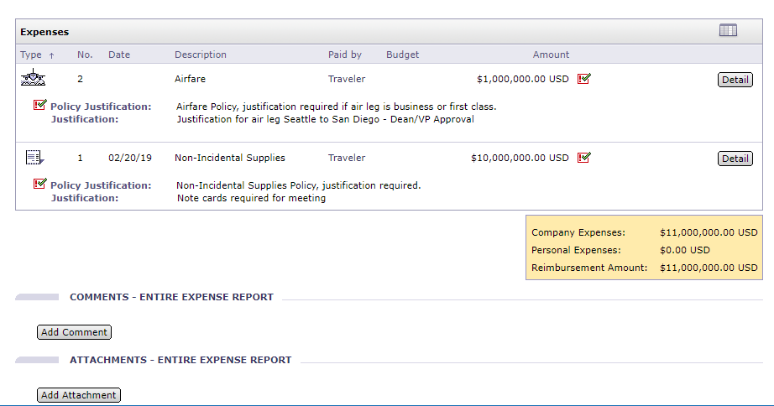

Fix instruction in ‘Package Deal’ line item
Added ‘expense report #’ to the information required to be sent to payroll for UW employee taxation.
Old: New:
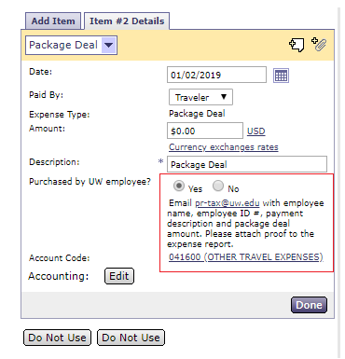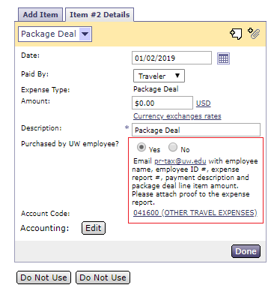

Add cancellation fee to ‘lodging per diem’ line item
This will be very similar to the ‘change fee’ functionality in the airfare line item. The main difference is it will act as an override and reduce the line item value down to the cancellation fee amount, instead of adding it to the total like it does for change fee in airfare.
Old: New:
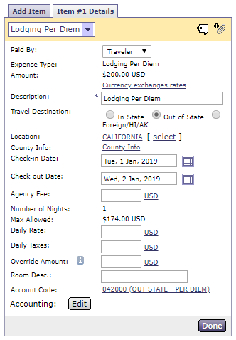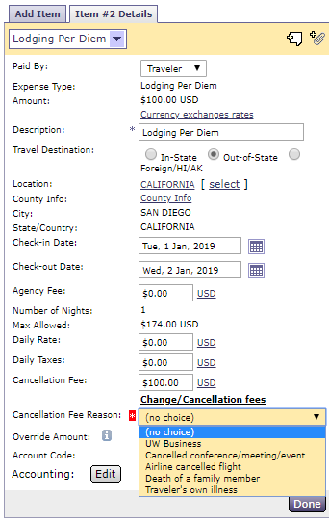

Travel Office approval flow flag changes
These predetermined flags add our office to the approval flow. Travel Office will focus the approval review to the high-risk flag(s) that prompted the Travel Office’s approval. Approval does not constitute a complete review of the expense report. Travel Office may perform random reviews to conduct a risk analysis.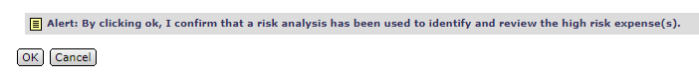

Old: | New:
Personal Time + Airfare | Personal Time + Airfare
Personal Time + Car Rental | Personal Time + Car Rental
Non Incidental Supply | Non Incidental Supply
Non-US + Visa Status | Non-US + B2/WT visa types
Living Allowance | Living Allowance
Per Diem Advance | Per Diem Advance
Relocation | Meal Paid for Other > $75.00
Meal Paid for Other | Not Sole Driver
1600 miles | Airfare Change Fee, UW Business
Rental SUV / Van / Truck / Other + UW Business | 1st Class airfare
Not Sole Driver | Business Class airfare – not 14hr rule
Airfare Change Fee, UW Business
1st Class
Business Class
Coach Upgrade

Add per diem city and state/country to print version and line item
The per diem city and state/country will now be visible on the print version of the expense report. Be sure to set the print configuration to view more details. Previously the field was blank. In the line item, the city and state can also be viewed instead of having to click into the per diem rate that was selected. These changes are the same for the lodging per diem and meal per diem line items.

Old:
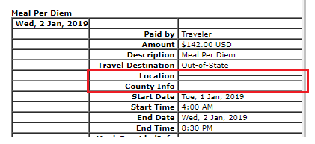
New:
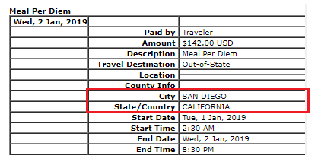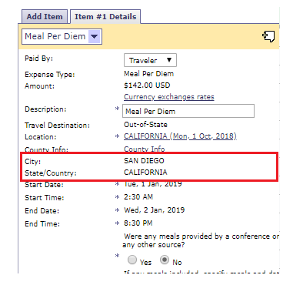

Changes to ‘meals paid for others’ line item
A couple questions have been added to assist with guiding compliance.
Old: New:
