Records Management Offboarding Checklist

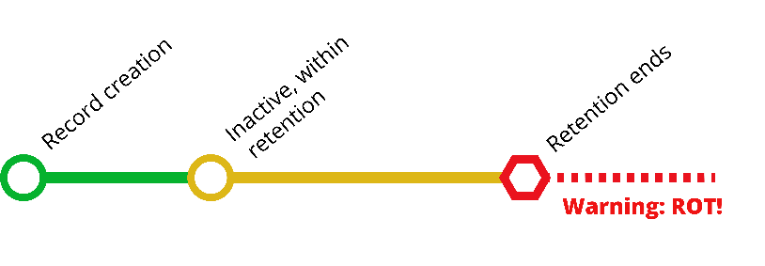
Leaving your position at the University? Use this checklist to ensure you appropriately transfer your paper, email and electronic records prior to your exit. This checklist covers active and inactive records, and how to identify, transfer, and preserve records using the UW General Retention Schedule and Department Retention Schedules as appropriate. For more details, see our page on Offboarding.

- Do not dispose of any records that are under destruction hold because of ongoing audits, litigation or public records requests. See our resource for more information.

- Dispose of records you have in your possession that have reached the end of their retention period or that you never needed to retain in the first place. For more information, refer to this list. If you need help with Redundant, Obsolete or Transitory records (ROT), contact the ROT Squad.

- Working with your manager, identify all substantive records and who should have access to them. Establish a plan ensuring the transfer occurs before your separation date.

- Contact Records Management Services if you have specific questions at recmgt@uw.edu.

Email
If you have emails that must be retained after you leave, follow these directions for Sharing Outlook Email Folders. If you have many folders, it may be easier to save a .pst file of your email on a departmental shared drive. To save a .pst file in Outlook Desktop version:
Click File>Open & Export>Import/Export>Export to a file>Create Outlook Data File.

Email | Share with | New Location
Active Records: records in the current workflow
☐ Approvals for purchases (example) | Joe Dawg | Placed into folder FY approvals and placed on shared drive
☐ | Add name(s)
☐
☐

Inactive Records: these are no longer being actively referenced, but must be retained for their full retention period.
☐ Approvals for purchases from 6 months ago (example) | Joe Dawg | Placed into folder FY approvals on shared drive
☐ | Add name(s)
☐
☐
Records Past Retention on Hold: these are records on destruction hold and must retained until the hold is lifted.
☐
☐
☐
Records Past Retention: delete these records immediately. Records past retention do not need to be retained.

Electronic Records
Make sure the appropriate individuals will have access to electronic records. For example, do not save records only under your own netid. Refer to our Best Practices for Folder Structures and Recommendations on File/Folder Naming Conventions for tips on how to save records.

Electronic Records | Share with | New Location
Active Records: these are records in the current workflow.
☐ SharePoint site for department (example) | Assign another owner, administrator or permissions manager | Same location
☐ | Add name(s)
☐
☐
Inactive Records: these are completed records but must be retained for their full retention period.
☐ Folders on departmental drive (example) | Joe Dawg | Shared drive
☐ | Add name(s)
☐
☐
Records Past Retention on Hold: these are records on destruction hold and must retained until the hold is lifted.
☐
☐
☐
Records Past Retention: delete these records immediately. Records past retention do not need to be retained.

Paper Records
Store all the paper records near each other so they can easily be spotted, and store similar records together (such as all the personnel records). Label folders clearly with the date that they can be destroyed in order to reduce confusion for future staff. Hand over keys to any locked storage locations to your supervisor.

Paper Records | Share with | New Location
Active Records: These are records in the current workflow.
☐ Bank Reconciliation (example) | Joe Dawg | File give to Ellen Pup
☐ | Add name(s)
☐
☐
Inactive Records: These are completed records but must be retained for their full retention period.
☐ Bank Reconciliation from 6 months ago (example) | Joe Dawg | Joe’s filing cabinet
☐ | Add name(s)
☐
☐
Records Past Retention on Hold: these are records on destruction hold and must retained until the hold is lifted.
☐
☐
☐
Records Past Retention: delete these records immediately. Records past retention do not need to be retained.
This checklist is transitory and can be disposed of as soon as it has outlived its usefulness. If you choose to retain a copy, please save it as part of the separating employee's departmental personnel file and dispose of it 3 years after termination of employment.

