Buying from Keeney’s with UW Pricing
As of July 2023, Keeney’s no longer has a catalog that campus can use to place orders. However, the UW still has a contract with Kenney’s. The instructions below will help you place an order with Keeney’s and get the UW contract pricing.

- Click on the link: http://store.keeneys.com<https://urldefense.com/v3/__http:/store.keeneys.com__;!!K-Hz7m0Vt54!jCHNx3NbTEDR6itYRZWzMDQSLDJ9DwZp_deJyC0bmt12bp_wUrNAPFz9YQ5_QB35T7fgUJqO4i-TUfJ9D2c$>

- Select the “Keeney”s Office Products | Office Interiors -Browse Home” from the Search results
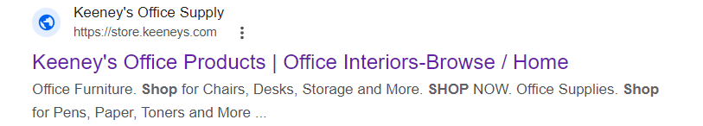

- From the Keeney’s dashboard, click the log in icon
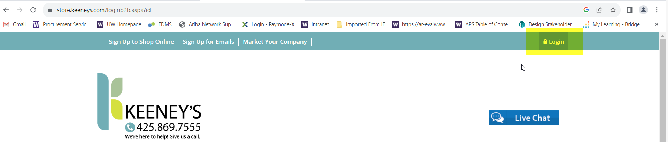

- Log in with the username and password:
  - Username: uwcatalog
Password: catalog

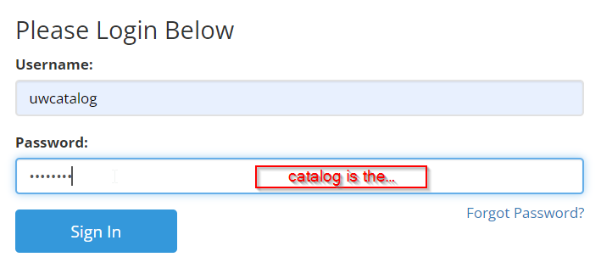

- You can then add items to your cart. When you are ready to check out, you will click the “Printer Friendly Version” of the cart that you can use as a guide to enter the items into Workday.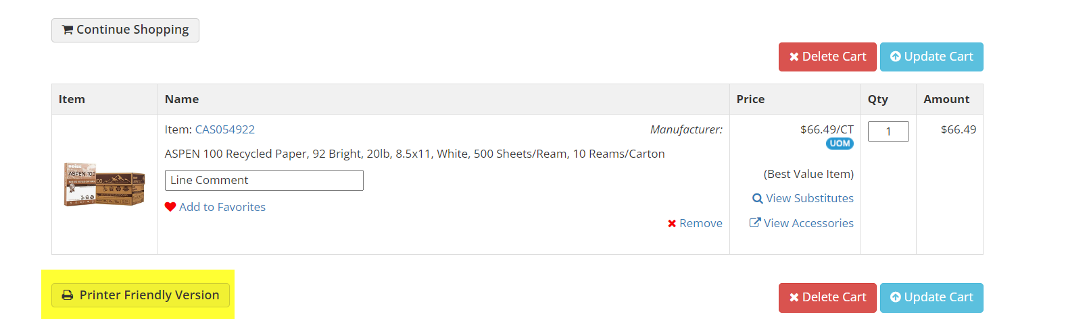
- Using Workday, create a “Goods or Services” Non-Catalog Purchase Order. Add the items based on the “Printer Friendly Version” you have on hand. Make the “Printer Friendly Version” an attachment on the requisition to show the pricing.

Utilize the job aids listed below for requisition entry:
- Job aid PRO-J-05 Requisitions for Requisition Requesters UWA
- Job aid PRO-J-14 Workday Create Requisition Addendum Deliver To (selecting Deliver to and Ship to addresses)

