Basic Airfare Expense
- Select Airfare from Add Item box

- Click Flight details box
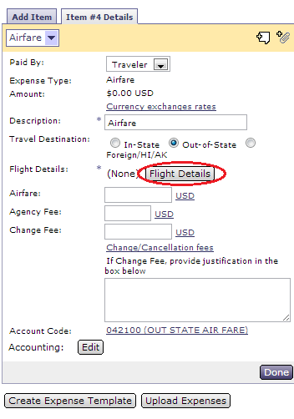
- Click Add
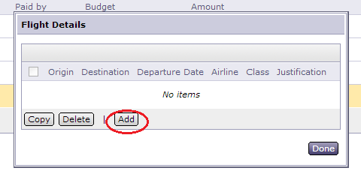
- Click grey circle with white arrow to select both origin and destination
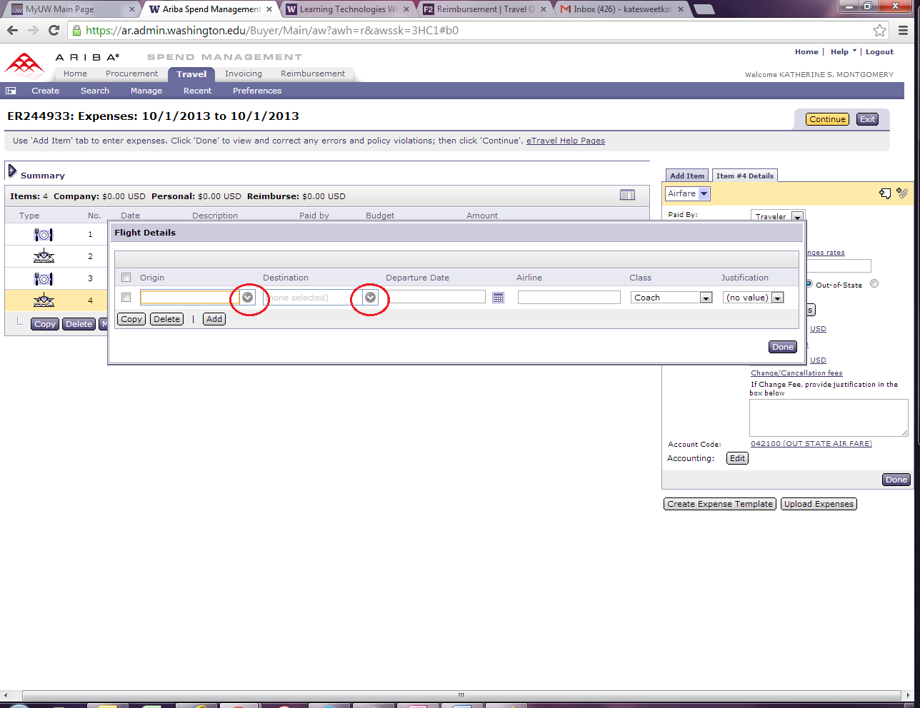
- Click Search for more…
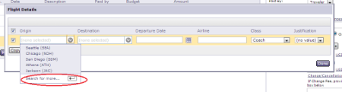
- Type in city, click search , click select
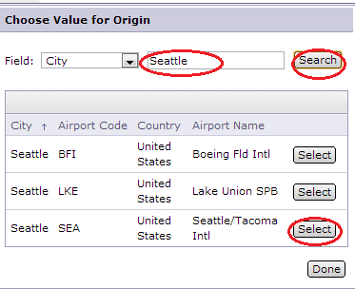
- Click on calendar icon to select date
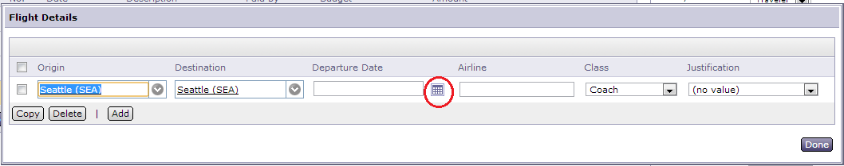
- Type in name of airline, Select class flown, anything other than coach requires justification, click done
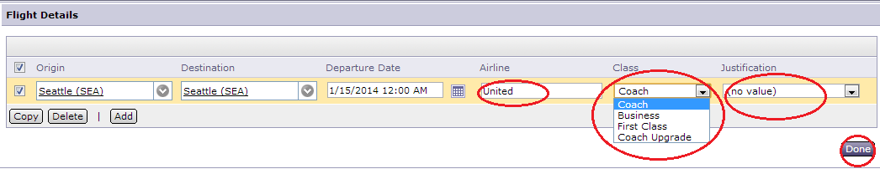
- Type in ticket price under amount, type in agency fee under fee, if change fee type in amount and enter justification, then click done
