We understand that browsers are updating on an ongoing basis. Here is one option for you if you would like to use Mozilla Firefox for Ariba. It is version 17, and will not update so will always be compatible with Ariba.  We know that there are security issues to think about. Please ensure you have checked with your IT department before using this browser.  We continue to work with Ariba to ensure we stay up to date with browser compatibility as they install updates.

Please feel free to contact [traveluw@uw.edu](mailto:traveluw@uw.edu) with any issues when using the Travel tab in Ariba. If you are experiencing issues in procurement, invoicing or reimbursement, please contact pcs help at [pcshelp@uw.edu](mailto:pcshelp@uw.edu)

1.  Click on the  
[**Mozilla Firefox for Ariba downloader here**](http://staff.washington.edu/mcnair/Ariba/Ariba%20Web%20Browser%20-%20FireFox%20ESR%20Portable.msi).

2. Click on **"Save File"**

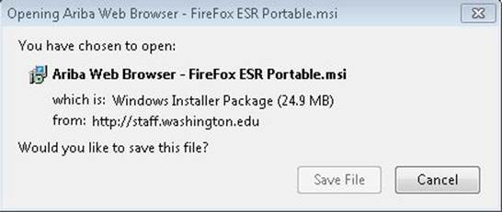

3.Open the downloaded file

4. Select **"Run"**

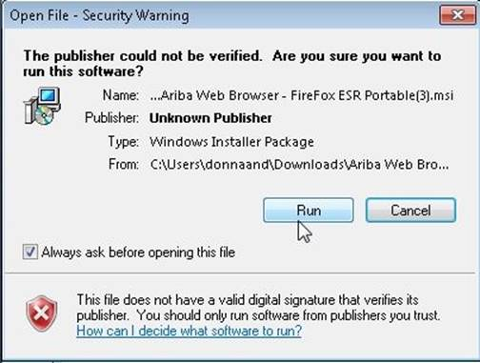

5. Follow the Script for the **Ariba Web Browser - Firefox ESR Portable Setup Wizard**

