Turning on the Analysis Toolpak Add-in

If you open the FEC QTR calculator, and you get result that look like below, then you must activate the Analysis Toolpak Add-in.

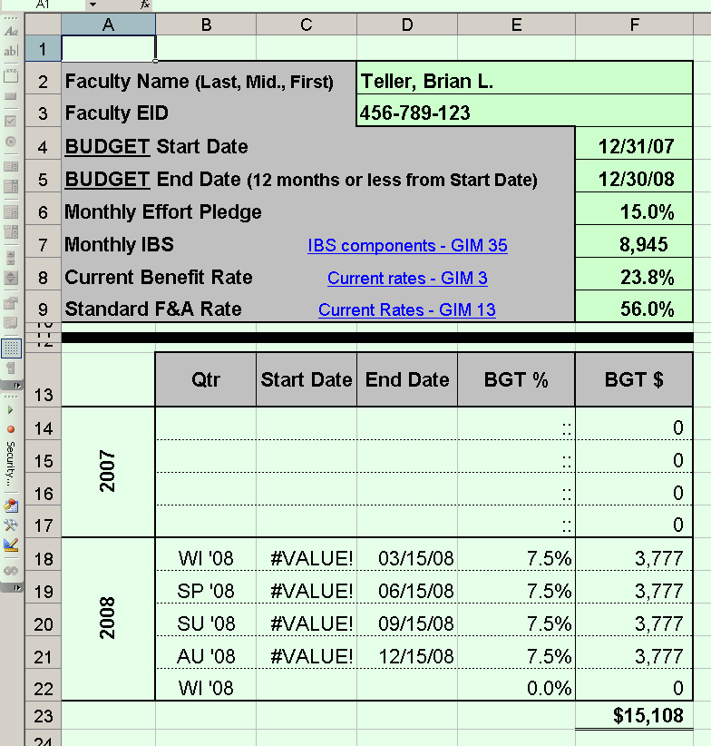

Excel 2003 (For Excel 2007 see page 4)
- Open Excel with a blank workbook.
- Select [Tools] from the top-line menu. Scroll down and click on “Add-Ins…”
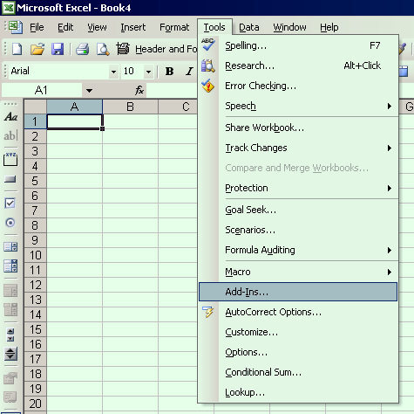
- From the dialog box that appears, click in the checkbox for “Analysis Toolpak” Then click [OK]
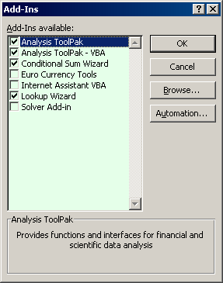
- Close the blank workbook.
- Now re-open the FEC calculator.
- You should now have a result that looks like the below.
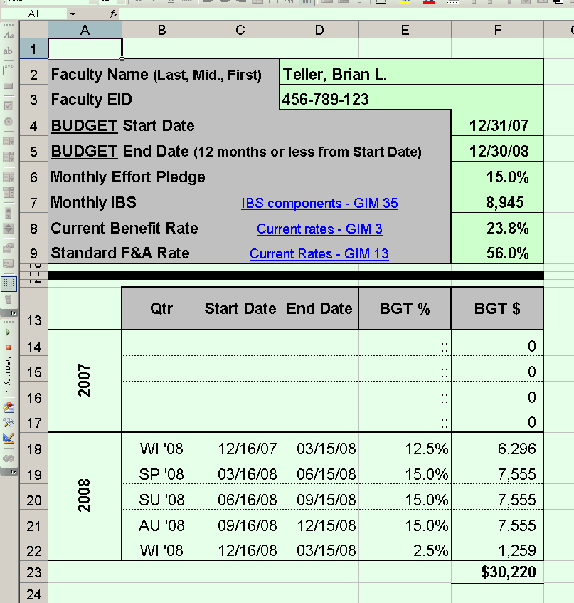

Excel 2007
- Open Excel with a blank workbook.
- Click on the Office button in the upper left corner (where Open, Save, Print, etc. are found) and select “Excel Options” at the bottom.
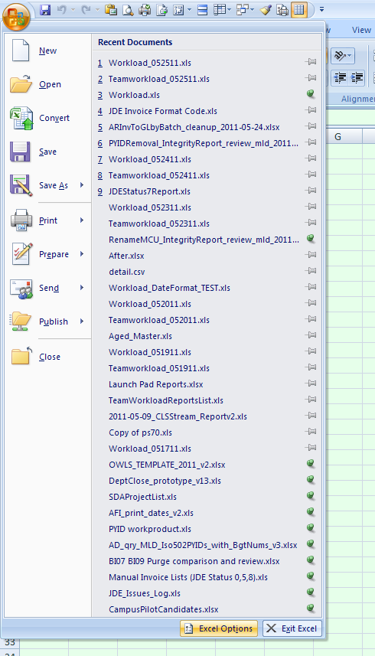
- In the Excel Options dialog, click [Add-Ins].
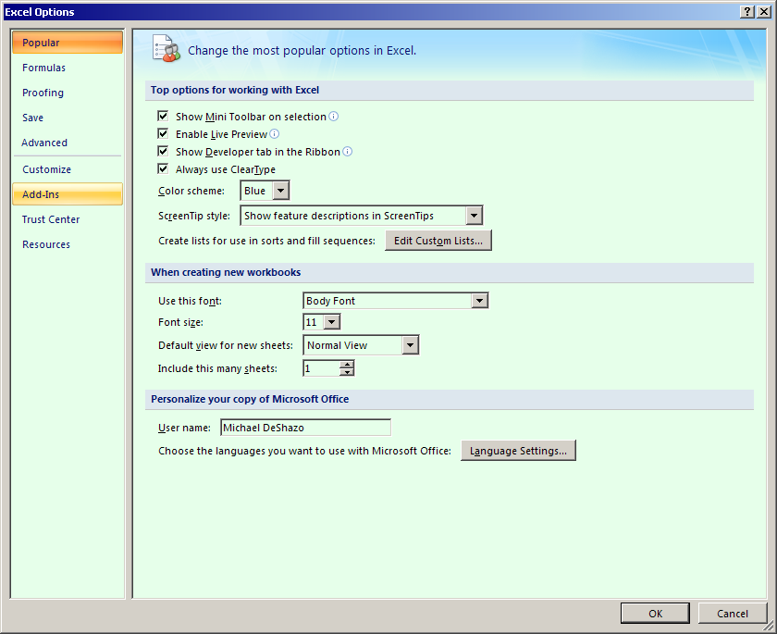
- At the bottom of the Add-ins screen, select “Excel Add-ins” from the drop-down list and click [Go].
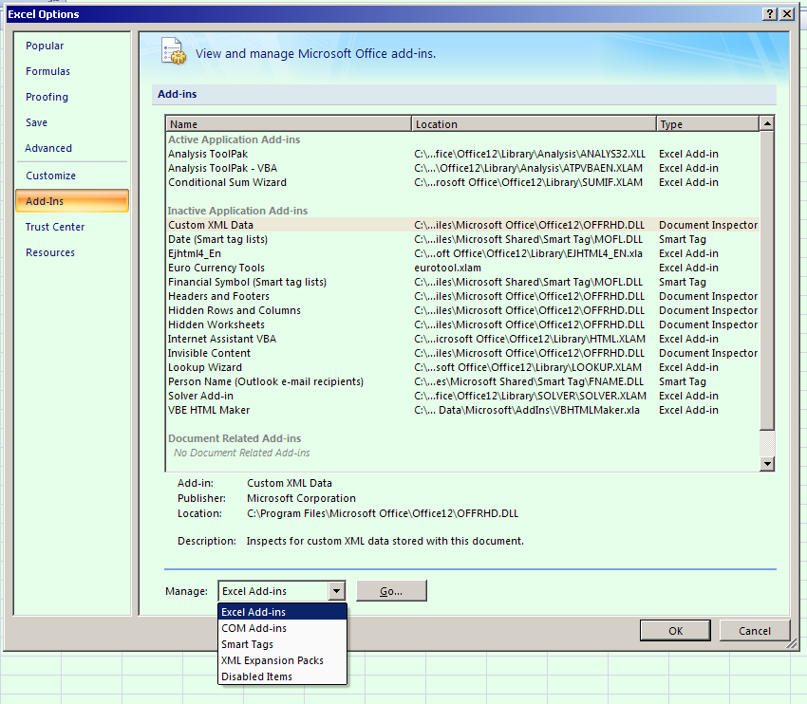
- From the dialog box that appears, click in the checkbox for “Analysis Toolpak” Then click [OK]
- Close the blank workbook.
- Now re-open the FEC calculator.
- You should now have a result that looks like the below.

