IRS special rules for Nonresidents completing the Form W-4
If a foreign national is not eligible or not claiming wage tax treaty, submits IRS Form W-4 Employee’s Withholding Allowance Certificate.
A Social Security number is required to complete IRS Form W-4.
Withholding will default to single and zero allowances if IRS Form W-4 is not submitted.
Special rules apply to nonresident aliens for tax purposes filling out IRS Form W-4.
If a nonresident does not complete the Form W-4 in the required manner above, the UW is required to treat the Form W-4 as invalid and withhold at "single with no allowances".
Please read instructions carefully.

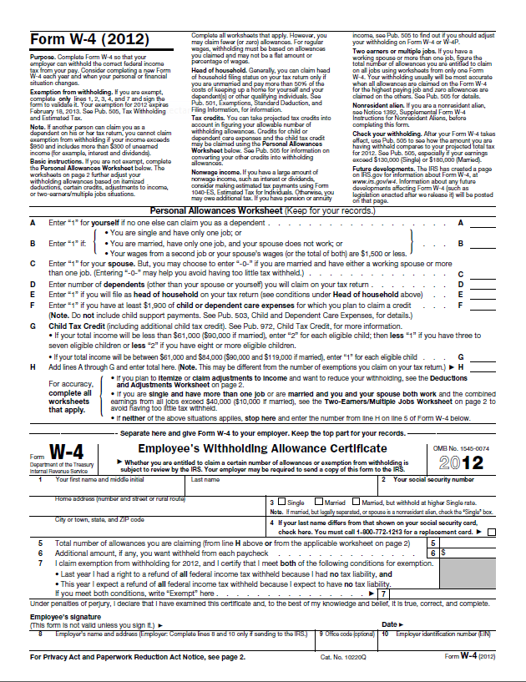
1
2
4
5
6
7
8
3a
3b
9

Instructions:
- Enter your first name, middle initial and last name.
- Enter your social security number. (Do not fill out this form if you do not have a Social Security number.)
3a. Enter your local address (number and street name).
3b. Enter City, State, and Zip code.
- Check single, regardless of actual marital status.
- Claim only one allowance.
(Residents of Canada, Mexico or Korea may claim more than one allowance.)
- Write "Nonresident Alien" or "NRA" above the dotted line on line 6 of the Form W-4.
- Do not claim "exempt"
(If you are "exempt" because of a tax treaty, complete IRS Form 8233.)
- Sign this form.
- Date this form.
Submit IRS Form W-4 to Payroll Office, Box 359555.
For more information please refer to IRS special rules for nonresidents (See IRS Publication)

