I-9 Form: Instructions for Nonresidents on H-lB or TN Visa
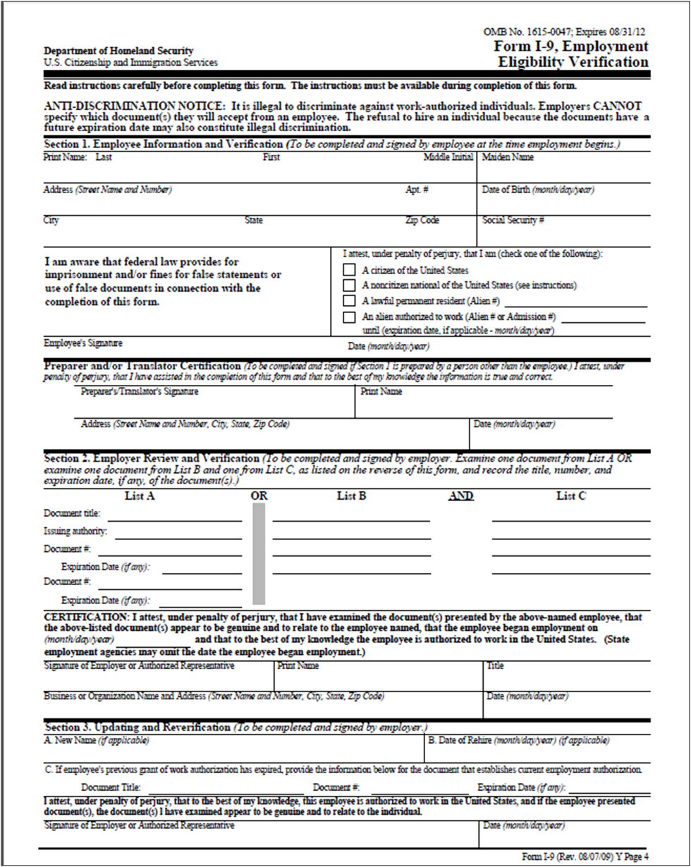
1
2
3
4
5
6
7a
7b
7
8
9
10
11
12
13
14
15
16
17
18
21
19
20
22
A
B
C1
C2
C3
D
E

I-9 Form: Instructions for Nonresident on H-1B or TN visa
Instructions for both New Hires and Updating & Reverification
_________________________________________________________
New Hire Instructions
Section 1. Employee Information and Verification
(To be completed and signed by employee at the time employment begins).

1. Enter your name (last name first, same as shown exactly on your social security card).
2. Enter your maiden name (if applicable).
3. Enter your address (street name and number).
4. Enter City, State, and Zip Code.
5. Enter your date of birth (month/day/year).
6. Enter your U.S. social security number. Note: Leave SSN box blank if SSN is not available at the time of hire.
7. Check this box (that you are a foreign national) if you are not a citizen of the U.S. or a permanent resident (green card holder).
7a. Enter the departure number from your Form I-94 (Departure Record).
7b. Expiration date - Enter the "until" date from your Form I-94 (Departure Record).
8. Employee should sign.
9. Enter the date that you completed this form.
10. To be completed and signed if Section 1 is prepared by a person other than the employee.

Section 2. Employer Review and Verification
(To be completed and signed by employer or authorized representative)
The following is an example of how to fill out the I-9 form when choosing from List A, #5 (unexpired foreign passport).

11. Document Title - Enter "PASSPORT".
12. Issuing Authority - Enter country that issued the passport.
13. Document Number - Enter the passport number.
14. Expiration date - Enter date the passport expires.
15. Document # - Enter the departure number from the Form I-94 (Departure Record).
16. Expiration date - Enter the "until" date from the Form I-94 (Departure Record).
- Confirm that the University of Washington is the sponsoring institution that obtained USCIS approval for visa classification.
- If the individual is employed past this date, the I-9 will need to be reverified. See reverification instructions below.

Section 2. Certification

17. Enter the date that the employee began employment in the department.
18. Employer or authorized representative should sign.
19. Print name of employer or authorized representative.
20. Enter title of employer or authorized representative.
21. Enter departmental name, address (mailbox).
22. Enter the date.

Submit the USCIS Form I-9 and the UW Form 1007 along with required copies documents (picture page of passport, I-94 Departure Record with stamp for TN, or I797 Notice of Action for H1B, I-94 with H-1B stamp) to the Payroll Office. Box 359555

Updating & Reverification Instructions
(To be completed, signed and dated by employer, if the employee is employed past the end date on
I-94 Departure Record with stamp for TN, or I797 Notice of Action for H1B, I-94 with H-1B stamp)
Section 1. Employee Information and Verification

Section 1. Employee Information and Verification

- Enter your name (last name first, same as shown exactly on your social security card)
6. Enter your U.S. social security number.

Section 3. Updating and Verification

A. Enter new name (if applicable).
B. Enter the date of rehire (if applicable).
C1. Document Title - Enter H-1B or TN.
C2. Document # - Enter the departure number from the I-94 Form (Departure Record).
C3. Expiration Date - Enter the “until” end date from the I-94 Form (Departure Record).
D. Employer or authorized representative should sign.
E. Enter the date that employer or authorized representative completed Section 3.

Submit the completed USCIS Form I-9 to Payroll Office, Box 359555

