I-9 Form: Instructions for Nonresidents on
Employment Authorization Card

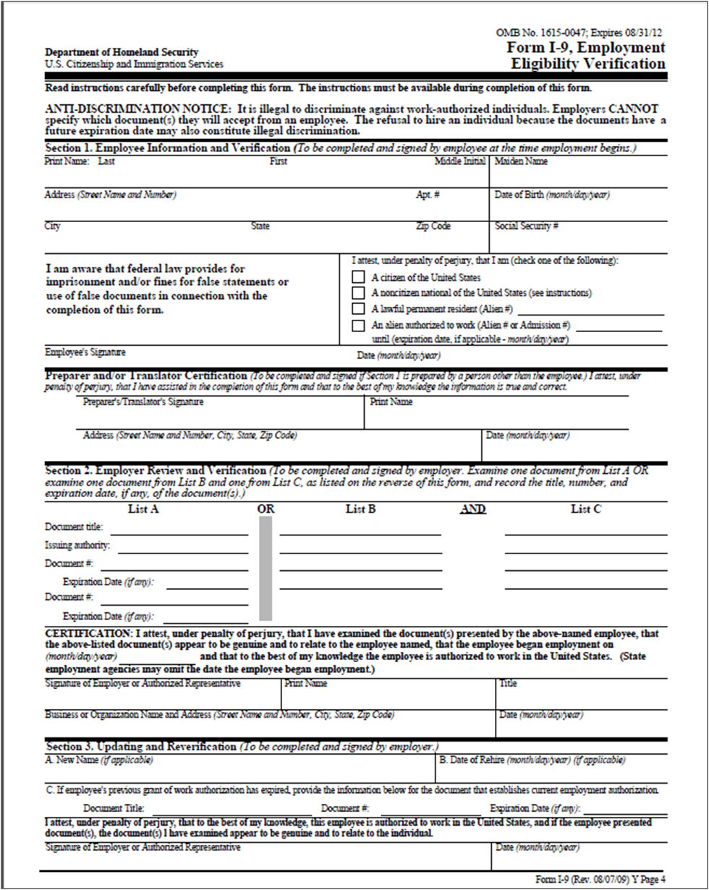
1
2
3
4
5
6
7a
7b
7
8
9
10
11
12
13
14
15
16
17
18
21
19
20
22
A
B
C1
C2
C3
D
E

I-9 Form: Instructions for Nonresidents on Employment Authorization Card
Instructions for both New Hires and Updating & Reverification
_________________________________________________________
New Hire Instructions
Section 1. Employee Information and Verification
(To be completed and signed by employee at the time employment begins).

1. Enter your name (last name first, same as shown exactly on your social security card).
2. Enter your maiden name (if applicable).
3. Enter your address (street name and number).
4. Enter City, State, and Zip Code.
5. Enter your date of birth (month/day/year).
6. Enter your U.S. social security number. Note: Leave SSN box blank if SSN is not available at the time of hire.
7. Check this box (that you are a foreign national) if you are not a citizen of the U.S. or a permanent resident (green card holder).
7a. Enter the USCIS number from your Employment Authorization Card.
7b. Enter the expiration date from your Employment Authorization Card.
8. Employee should sign.
9. Enter the date that you completed this form.
10. To be completed and signed if Section 1 is prepared by a person other than the employee.

Section 2. Employer Review and Verification
(To be completed and signed by employer or authorized representative)
The following is an example of how to fill out the I-9 form when choosing from List A, #4 (Employment Authorization Document that contains a photograph (Form I-766))

11. Document Title - Enter "Employment Authorization Card"
12. Issuing Authority - Enter "USCIS"
13. Document Number - Enter the Employment Authorization Card number USCIS number.
14. Expiration date - Enter expiration date from the Employment Authorization Card.
15. Document # - Leave blank.
16. Expiration date - Leave blank.
- If the individual is employed past this date, the I-9 will need to be reverified by completing Section 3 of the I-9. See instructions below.

Section 2. Certification
17. Enter the date that the employee began employment in the department.
18. Employer or authorized representative should sign.
19. Print name of employer or authorized representative.
20. Enter title of employer or authorized representative.
21. Enter departmental name, address (mailbox).
22. Enter the date.

Submit the USCIS Form I-9 and the UW Form 1007 along with a copy of Employment Authorization Card to the Payroll Office. Box 359555

Updating & Reverification Instructions
(To be completed, signed and dated by employer, if the employee is employed past the expiration date on the Employment Authorization Card).

Section 1. Employee Information and Verification

1. Enter your name (last name first, same as shown exactly on your social security card)
6. Enter your U.S. social security number.

Section 3. Updating and Verification

A. Enter new name (if applicable).
B. Enter the date of rehire (if applicable).
C1. Document Title - Enter "Employment Authorization Card".
C2. Document # - Enter the number (USCIS A#) from the Employment Authorization Card.
C3. Expiration Date - Enter the date from the Employment Authorization Card.
D. Employer or authorized representative should sign.
E. Enter the date that employer or authorized representative completed Section 3.

Submit the completed USCIS Form I-9 to Payroll Office, Box 359555

