Asset Transfers UW8161 & School of Medicine
TRANSFER is used:
- To change an existing location
(or add one if you forgot to do this during “Issue to Worker”)
- Change an existing “Issued To” person.
- Change an existing Worktag, usually the Cost Center but can be a change to any other Worktag such as fund, function, grant, or resource.
  - Unit Asset Coordinators may only initiate transfers within the same company (Intracompany transfer)
  - If you want to request a transfer to a different company (e.g., UW1861 assets transferred to School of Medicine) please submit a UW connect request form.
Please review the information below to learn how “Transfer” has been configured at UW:
Transfer is used to: | Can be Initiated by: | Approvals required?
1. Change an existing asset location.  exception: if when you “Issued” an asset to a custodian for the first time, you forgot to add the asset location information to the Issue to Worker screen, you may use “Transfer” to add a location. | Unit Asset Coordinator  Business Asset Tracking Specialist  Business Asset Accountant | No
2. Change an existing “Issued to” person  to a different “Issued to” person | Unit Asset Coordinator  Business Asset Tracking Specialist  Business Asset Accountant | No
3. Change an existing Worktag, usually the Cost Center, but also includes changes to a fund, function, grant, or resource Worktag.  *See page 2 for details on updates to cost centers | Unit Asset Coordinator  Business Asset Tracking Specialist  Business Asset Accountant | Yes
Approvals Required for Worktag changes (#3)
Change submitted by:  Unit Asset Coordinator | Change submitted by:  Business Asset Tracking Specialist | Change submitted by:  Business Asset Accountant
1. Routes to Business Asset Tracking Specialist for approval | 1. Routes to the FROM Cost Center Manager for approval | 1. Routes to the FROM Cost Center Manager for approval
2. Routes to the FROM Cost Center Manager for approval | 2. Routes to the TO Cost Center Manager for approval | 2. Routes to the TO Cost Center Manager for approval
3. Routes to the TO Cost Center Manager for approval

Details on updating cost center worktag using Transfer:
To get to the Transfer screen: from the related actions menu, pick Business Asset, then Transfer
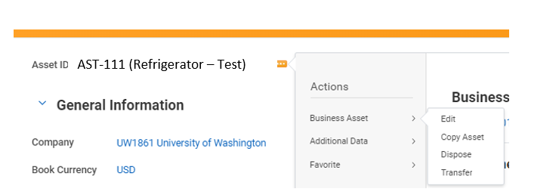
Updating the cost center on the “Transfer Asset” screen to a different cost center within the same balancing unit:
- You will see the “Current” Worktags displayed on the right.
- you may add or update worktags using the column on the left: “Transfer To Values”
- If you are transferring to a different COST CENTER, and are doing a search, you will only see the Cost Centers Available in the Balancing Unit displayed in the “Additional Worktags” section. Example:
  - If BU102 Bothell, is in the additional worktags section, when searching in the “Cost Center” box for a different cost center, you will only see Cost centers mapped to BU102.

How to transfer an asset to a different balancing Unit:
Scenario: An asset belonging to BU102 Bothell is going to be transferred to BU132, College of Engineering
- The Unit Asset Coordinator (UAC) from Bothell, should prepare for the transfer:
  - Determine the desired “Transaction Effective Date”
  - Contact the Unit Asset Coordinator from BU132 for the other “transfer to” values :
    - Transfer To worker name
    - Transfer to location
    - Other desired worktags, e.g. ask for the new cost center, and resource tag. The cost center will populate the Balancing Unit and Function worktags, the Resource tag will populate the Fund tag
      - Note you will need to REMOVE the worktag BU102 (Bothell) to search for cost centers outside of Bothell.

